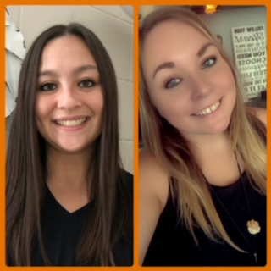Dear Huron Middle School Students and Parents:

Welcome to the 2021-2022 school year! We hope that you all had a wonderful summer and are ready to head back to school! We are very excited to begin this school year with you!

If you are new to Huron Middle School or a returning student this year, we look forward to working with you. We would like to take this opportunity to explain a little bit about the Huron Middle School counseling/social work program. We have one school counselor and one school social worker in the middle school this year.

Ms. Sieh

Mrs. Decker

\*\*\***Ms. Sieh** is the school counselor and this will be her 7th year at HMS**. She will be working with 8th grade students as well as 7th grade students with last names beginning with letters A-M.**

\*\*\***Mrs. Decker** is our new social worker and this will be her first year at HMS. **She will primarily work with 6th grade students and 7th grade students with last names beginning with letters N-Z.**

As a counseling office we provide small group sessions, individual sessions, and assistance with academic needs. We also work with parents and teachers to help support their student(s) in school.

Many of the things we help students work on are considered life skills. During visits with us students may view a video, play a game, hear a story, or participate in other activities that reinforce the life skill we are working on. Some examples of life skills that we help students with are respect for self and others, emotional regulation, decision making, goal setting, responsibility, problem solving, appreciation of others, organizational skills, and college and career exploration. We also work with teachers and other staff to present lessons on anti-bullying, diversity, internet and social media awareness, and healthy relationships.

Some students we work with may participate in small group sessions of 4-8 students. Topics relevant to the participants’ needs are chosen for the group (i.e. divorce, healthy friendships, grief and loss, etc.). Students for each group will be identified based on referrals from parents or what seems to be trending in the counseling office.

Children may also visit with us individually. Parents and staff members may refer a child for individual or group sessions. Students may also request a visit. Although we do not provide clinical therapy or intensive services at school, we are here to help each student be successful at HMS.

If there are any concerns throughout the year and you would like our assistance please call us at Huron Middle School, (605)353-6900, or send an email at [akina.decker@k12.sd.us](mailto:akina.decker@k12.sd.us) or [heather.sieh@k12.sd.us](mailto:heather.sieh@k12.sd.us).

We are looking forward to a great year!

Sincerely,

Heather Sieh Akina Decker

Professional School Counselor Certified School Social Worker